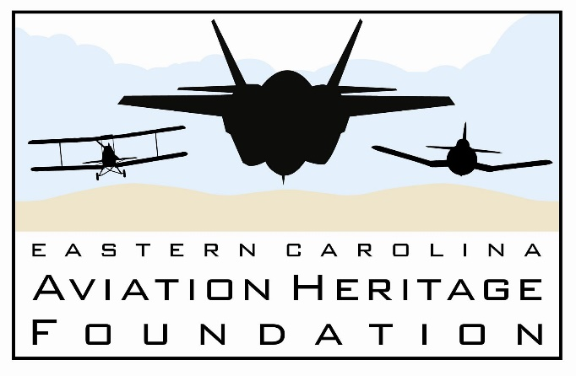
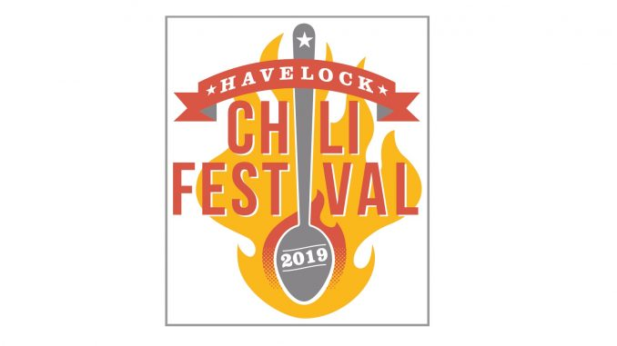

Look for us at the
2019 Havelock Chili Festival
Walter B. Jones Park
October 18 and 19, 2019

ECAHF will have a booth set up with an ejection seat for a photo opportunity, pilot flight suit, giveaways, and information about the foundation. We hope to see you there!

